# **Name: Abdur R. Qureshi**

# **Roll No: 242466**

Practical No: 7

Date Of Performance: 11/09/2025

Aim: Implementation of Hello World Application using React CDN/ CRA/ Vite.

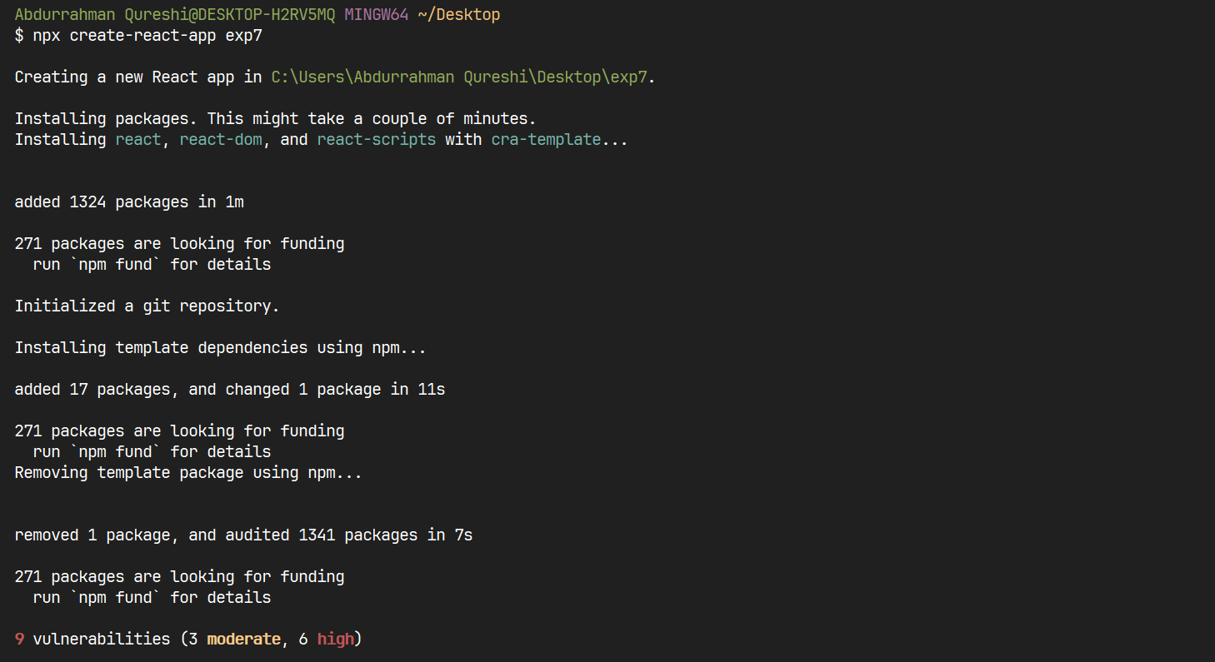

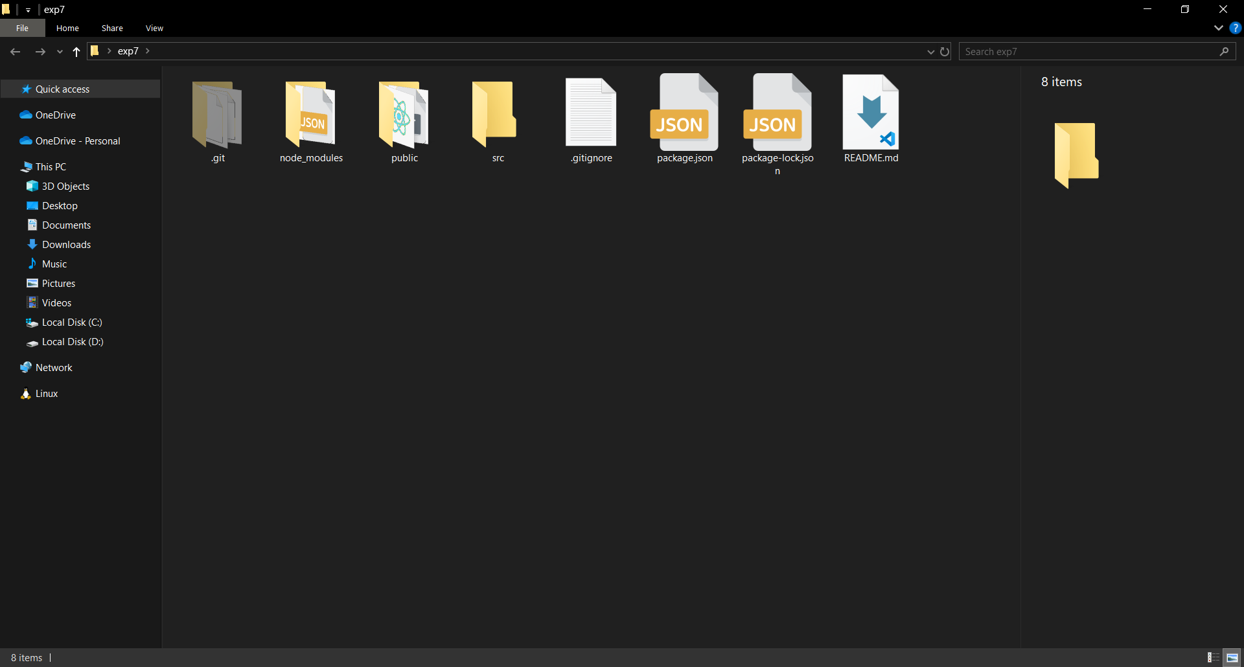

CODE:

import './App.css';

function App() {

  return (

    <>

      Hello World

      <br />

      EXP7 - 242466

    </>

  );

}

export default App;

OUTPUT:

